Name: ANSWERS

Year 9 Science Revision 2019
- Complete the following table about sub-atomic particles (parts of an atom):
Name of particle | Location of particle in an atom | Electric charge of particle | Relative size of particle.  (Ie largest or smallest)
Proton | The nucleus of the atom | +1 | Equal largest (10,000 times larger than the electron)
Neutron | The nucleus of the atom | No charge | Equal largest
Electron | Around the outside of the nucleus | -1 | The smallest particle in an atom

- What is the difference between an element and a compound?
Element has only one type of atom in it, but a compound has more than one type of atom
- What is the difference between an ion and an atom?
An ion is an atom, or group of atoms with a charge. An atom has no charge.
- When magnesium is burned, the magnesium combines with oxygen to form a white substance called Magnesium Oxide
  - List the reactants of the chemical reaction described above:
Magnesium, oxygen
  - List the products of the chemical reaction described above:
Magnesium Oxide
  - Write the word equation for the reaction described above: (Use an arrow to separate reactants and products)
Magnesium + oxygen → Magnesium Oxide

- How can you prevent a metal from rusting?
Rusting is the reaction between a metal and oxygen, so keeping oxygen from getting to the metal could be done by painting the metal, or covering it in a grease or oil layer.

- Complete the following table which relates to the number of electrons that can fit into an electron shell of an atom:
Shell position from nucleus | Number of electrons that can fit in the shell
1st shell | 2
2nd shell | 8
3rd shell | 8

- Draw the arrangement of electrons around the following atoms:
Fluorine (9 electrons) Sodium (11 electrons) Potassium (19 electrons)
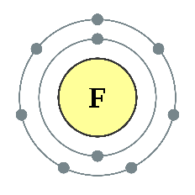
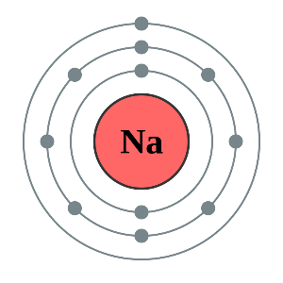
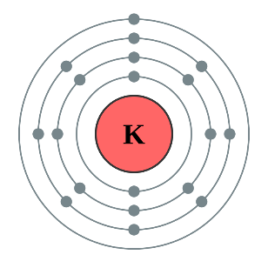
- The word equation for igniting hydrogen gas in air (oxygen) is:
Hydrogen + Oxygen Water
List the product/s: Water
List the Reactant/s: Hydrogen, Oxygen

- List the signs that a chemical reaction has taken place.
Colour change Precipitate (solid) forms Gas is given off (bubbling)
Temperature change Change in odour or taste

- State the law of conservation of mass.
In any chemical reaction mass (matter) cannot be created or destroyed and must be conserved

- What is the difference between endothermic and exothermic chemical reactions?
Exothermic reactions release heat and therefore make their surrounding hotter. Exothermic reactions have heat (or energy) as a product (on the right hand side) in the chemical equation . Endothermic reactions absorb energy from their surroundings and therefore make their surroundings colder. Endothermic reactions have heat (or energy) as a reactant (left hand side) in the chemical equation.

- Use the periodic table and your knowledge from class to complete the following table:

Element | Symbol | Atomic Number | Atomic Mass | Number of Protons | Number of Neutrons
Magnesium | Mg | 12 | 24 | 12 | 12
Oxygen | O | 8 | 16 | 8 | 8
Sulphur | S | 16 | 32 | 16 | 16
Aluminium | Al | 13 | 27 | 13 | 14
Helium | He | 2 | 4 | 2 | 2

- Read the following passage describing a chemical reaction that you did in class:

Potassium Iodide and Lead Nitrate are both clear liquids. When they are added together the liquid instantly turned bright yellow. This is due to a substance called Lead Iodide being formed along with another substance called Potassium Nitrate.
- List the products of the reaction: Lead Iodide and Potassium Nitrate
- List the reactants of the reaction: Potassium Iodide and Lead Nitrate
- Write a word equation (using an arrow to separate the reactants and the products) for the chemical reaction:
Potassium Iodide + Lead Nitrate → Potassium Iodide + Lead Nitrate

- Fill in the missing name and chemical diagram for the following chemical reaction:

Copper + Hydrogen Sulphate Copper Sulphate + Hydrogen gas
S
O
O
O
S
O
O
O
H
Cu
H
H
Cu
H

- Your friend made excellent revision notes on Radiation, but you notice they have left out what the Alpha, Beta particles are comprised of. Add the following terms to the diagram;
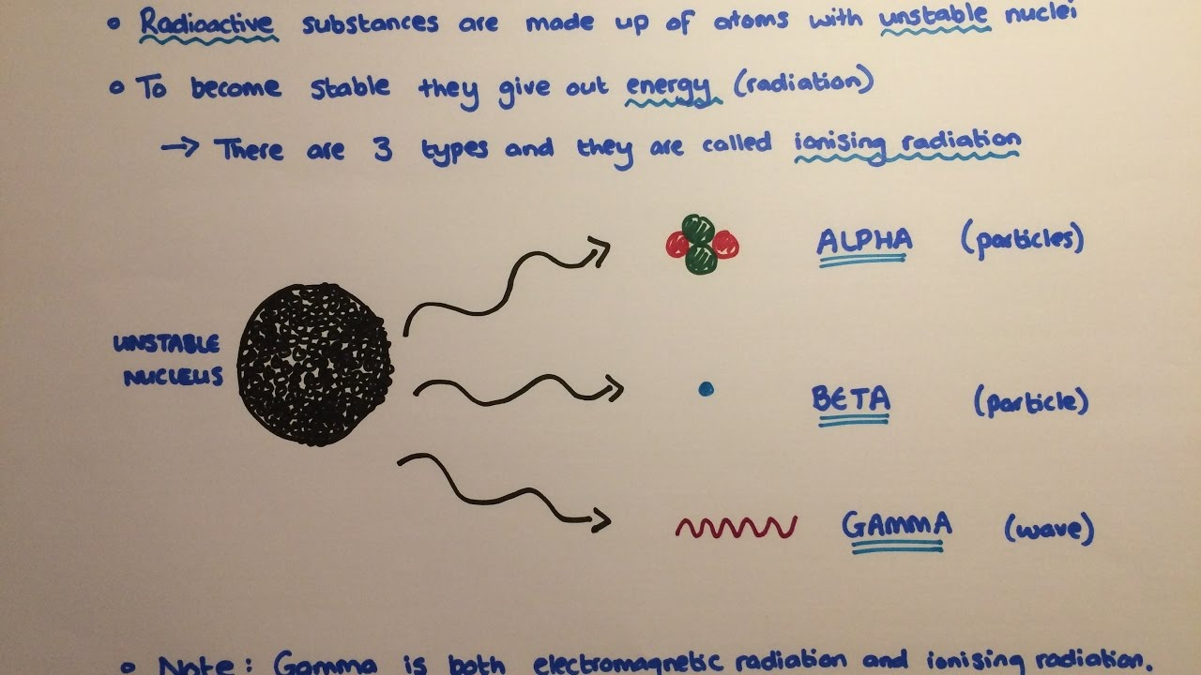
- 2 protons and 2 neutrons
2 protons and 2 neutrons
electron
- Electron

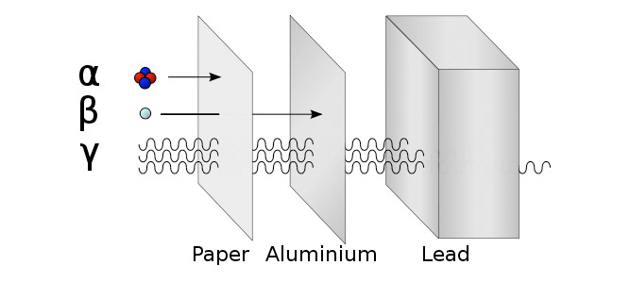
- Using the information from the notes above. Explain the following diagram in the space provided below.

The diagram explains how the three types of radiation can penetrate matter. Alpha particles are the largest radioactive particle and are stopped by a single sheet of paper. Beta particles are much small and can penetrate further but are stopped by most metals. Gamma radiation is not a particle and penetrates the most. Gamma radiation is stopped by several centimetres of lead metal.

- Explain the difference between combustion and Oxidation.
While both of these involve a reaction with oxygen they differ in many way.
- Oxidation involves a metal reacting with oxygen, while combustion involves a non-metal reacting with oxygen.
- Oxidation is quite slow, but most combustion reactions are very quick (burning).
- Oxidation reactions release energy very slowly, but combustion reactions are very exothermic and release a lot of energy as heat, very quickly.

